Great Circle
# Source: AI Source: Provided by: [Data Path: Persons Table -> ID Column: 1, Name_En Column: Motasem Essam] -> From: [ChatGPT] on [7/25/2026]
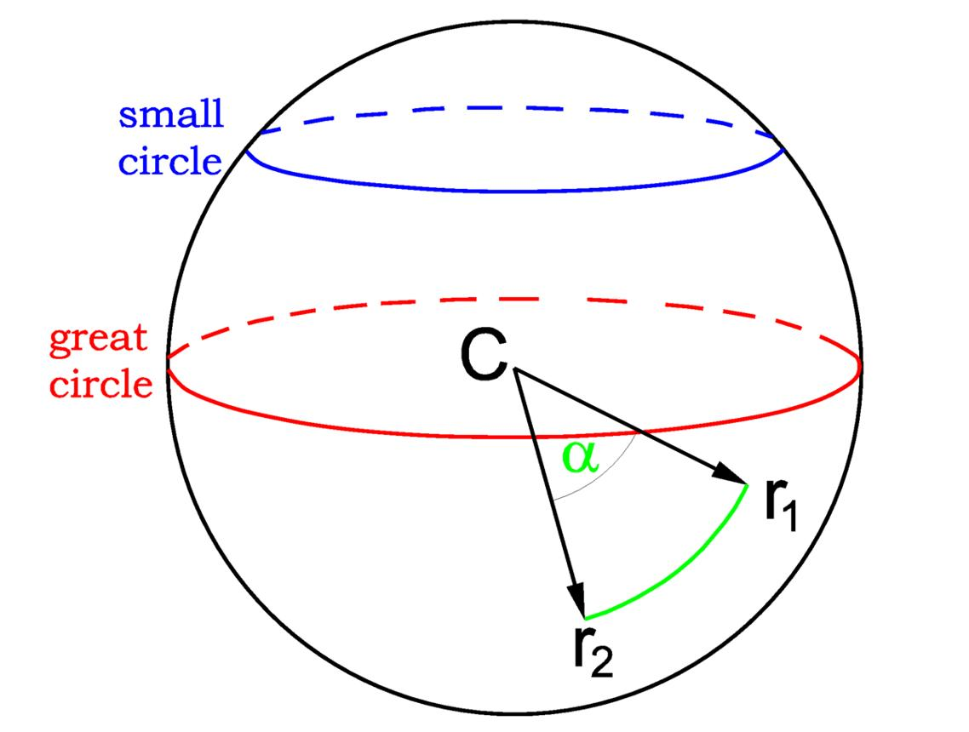
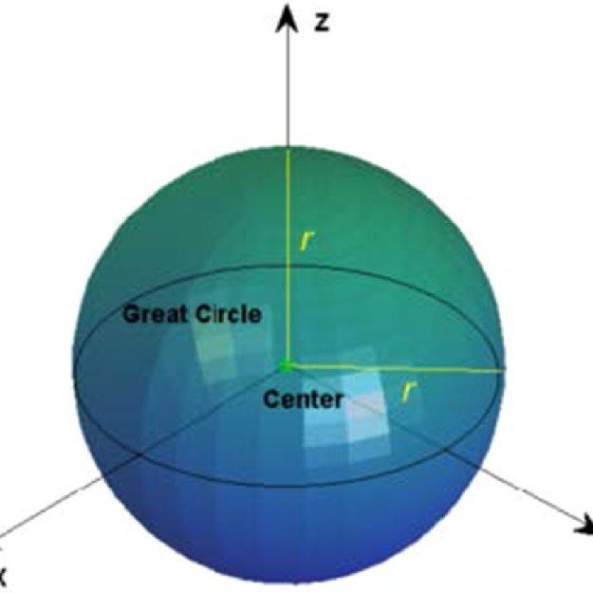
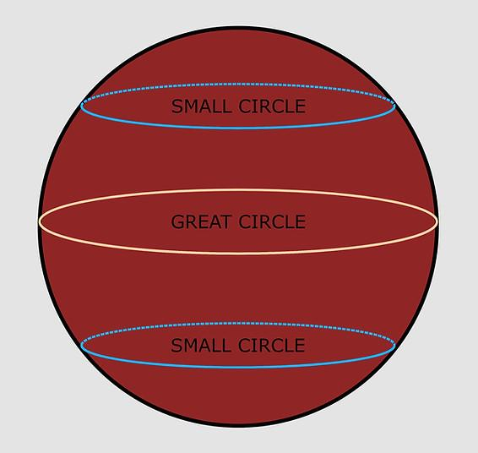

Definition
# Source: AI Source: Provided by: [Data Path: Persons Table -> ID Column: 1, Name_En Column: Motasem Essam] -> From: [ChatGPT] on [7/25/2026]
A great circle is a circle formed by the intersection of a sphere with a plane that passes through the sphere's center. It is the largest possible circle that can be drawn on a sphere's surface.
A great circle divides the sphere into two equal hemispheres. Its radius is equal to the sphere's radius.

Simple Definition
# Source: AI Source: Provided by: [Data Path: Persons Table -> ID Column: 1, Name_En Column: Motasem Essam] -> From: [ChatGPT] on [7/25/2026]
A great circle is a circle drawn around a sphere so that its plane passes through the center of the sphere.
For example, Earth's equator is a great circle because its plane passes through Earth's center.

Types and Orientations of Great Circles
# Source: AI Source: Provided by: [Data Path: Persons Table -> ID Column: 1, Name_En Column: Motasem Essam] -> From: [ChatGPT] on [7/25/2026]
A great circle is defined by its relationship to the sphere's center. Different great circles can be oriented in different directions.

Equatorial Great Circle
# Source: AI Source: Provided by: [Data Path: Persons Table -> ID Column: 1, Name_En Column: Motasem Essam] -> From: [ChatGPT] on [7/25/2026]
A great circle whose plane is perpendicular to the sphere's chosen polar axis. On Earth, the equator is the standard example.
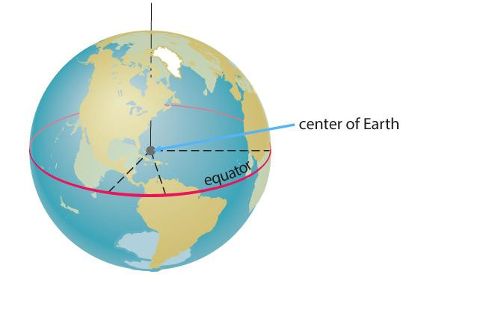

Meridional Great Circle
# Source: AI Source: Provided by: [Data Path: Persons Table -> ID Column: 1, Name_En Column: Motasem Essam] -> From: [ChatGPT] on [7/25/2026]
A great circle whose plane contains the polar axis. On Earth, a complete meridian circle passes through both the North and South Poles.
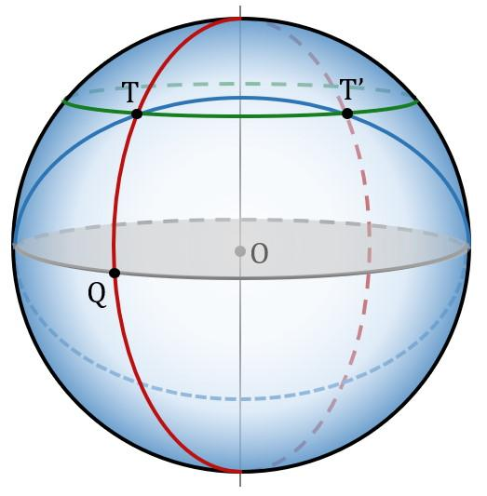

Inclined Great Circle
# Source: AI Source: Provided by: [Data Path: Persons Table -> ID Column: 1, Name_En Column: Motasem Essam] -> From: [ChatGPT] on [7/25/2026]
A great circle whose plane passes through the center but is inclined relative to a chosen reference plane, such as the equatorial plane.
Note: These are descriptive orientations, not separate mathematical kinds of great circles. Every plane passing through a sphere's center produces a great circle.
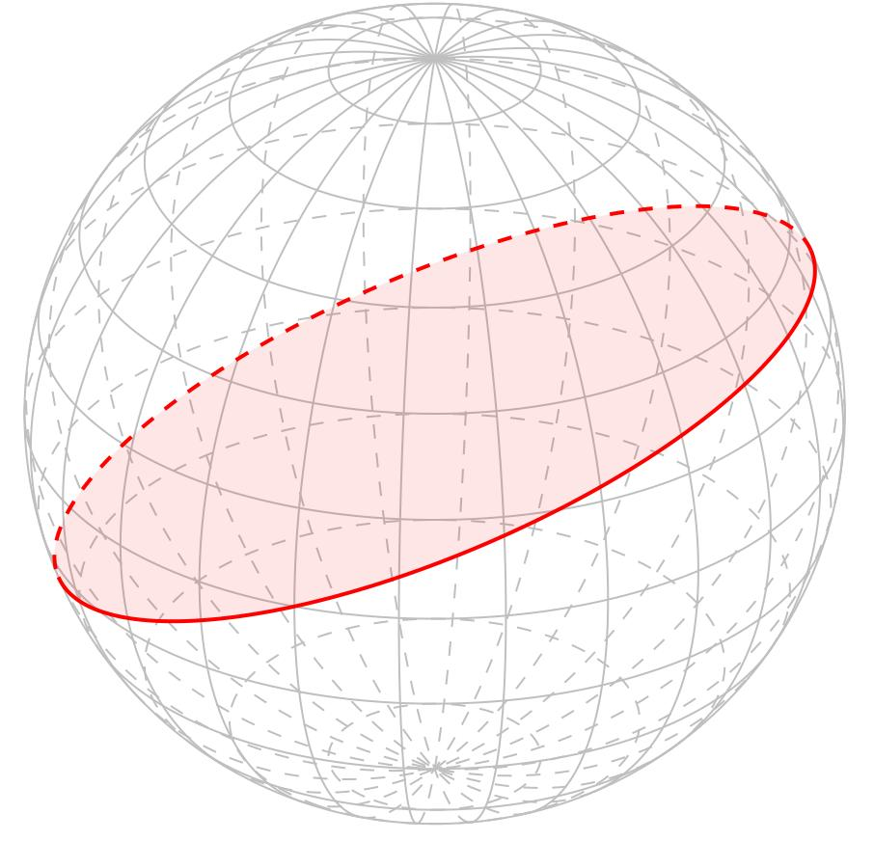

Key Characteristics
# Source: AI Source: Provided by: [Data Path: Persons Table -> ID Column: 1, Name_En Column: Motasem Essam] -> From: [ChatGPT] on [7/25/2026]
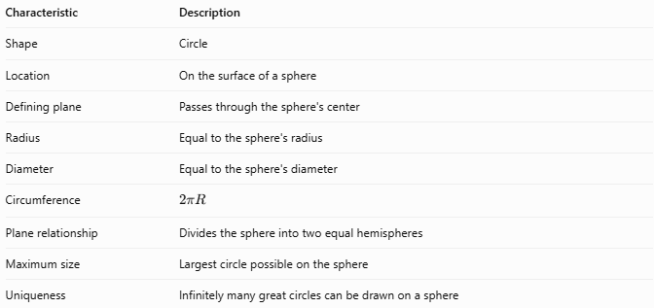
Characteristic | Description
Shape | Circle
Location | On the surface of a sphere
Defining plane | Passes through the sphere's center
Radius | Equal to the sphere's radius
Diameter | Equal to the sphere's diameter
Circumference | $$2πR$$
Plane relationship | Divides the sphere into two equal hemispheres
Maximum size | Largest circle possible on the sphere
Uniqueness | Infinitely many great circles can be drawn on a sphere

Geometric Components
# Source: AI Source: Provided by: [Data Path: Persons Table -> ID Column: 1, Name_En Column: Motasem Essam] -> From: [ChatGPT] on [7/25/2026]
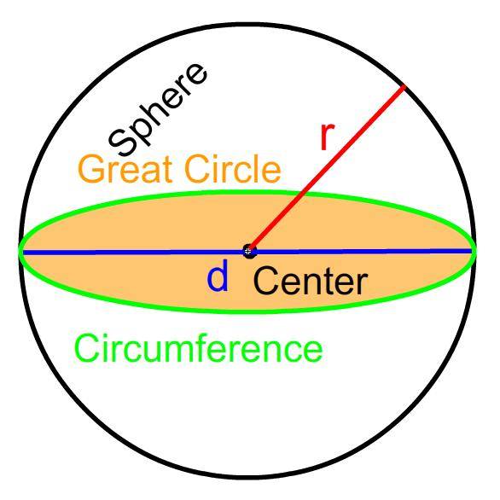
- Sphere: The three-dimensional solid whose surface contains the great circle.
- Great circle: The circular intersection of the sphere and a plane through its center.
- Center ($O$): The center of the sphere and the center of the great circle.
- Radius ($R$): Distance from the sphere's center to any point on its surface.
- Diameter ($D$): A line through the center connecting two opposite points on the sphere; $D=2R$.
- Great-circle plane: The plane passing through the center and containing the great circle.
- Hemispheres: The two equal halves created when the sphere is divided by the great-circle plane.

Mathematical Representations and Formulas
# Source: AI Source: Provided by: [Data Path: Persons Table -> ID Column: 1, Name_En Column: Motasem Essam] -> From: [ChatGPT] on [7/25/2026]
Let $R$ be the radius of the sphere.

Radius of a Great Circle
# Source: AI Source: Provided by: [Data Path: Persons Table -> ID Column: 1, Name_En Column: Motasem Essam] -> From: [ChatGPT] on [7/25/2026]
Because the plane passes through the sphere's center, the great circle has the same radius as the sphere.
$$\boxed{r_{g}=R}$$

Diameter
# Source: AI Source: Provided by: [Data Path: Persons Table -> ID Column: 1, Name_En Column: Motasem Essam] -> From: [ChatGPT] on [7/25/2026]
$$\boxed{D=2R}$$

Circumference
# Source: AI Source: Provided by: [Data Path: Persons Table -> ID Column: 1, Name_En Column: Motasem Essam] -> From: [ChatGPT] on [7/25/2026]
The circumference of a great circle is:
$$\boxed{C=2πR}$$

Area Enclosed by a Great Circle
# Source: AI Source: Provided by: [Data Path: Persons Table -> ID Column: 1, Name_En Column: Motasem Essam] -> From: [ChatGPT] on [7/25/2026]
The area of the flat circular disk bounded by the great circle is:
$$\boxed{A=πR^{2}}$$
This is the area of the disk in the plane, not the curved surface area of the sphere.

Relationship to Sphere Surface Area
# Source: AI Source: Provided by: [Data Path: Persons Table -> ID Column: 1, Name_En Column: Motasem Essam] -> From: [ChatGPT] on [7/25/2026]
The total surface area of the sphere is:
$$A_{s}=4πR^{2}$$
Therefore, the disk area is one-quarter of the sphere's total surface area:
$$\boxed{A={\frac{1}{4}A}_{s}}$$

Relationship to Sphere Volume
# Source: AI Source: Provided by: [Data Path: Persons Table -> ID Column: 1, Name_En Column: Motasem Essam] -> From: [ChatGPT] on [7/25/2026]
The sphere's volume is:
$$V=\frac{4}{3}{πR}^{3}$$
A great-circle plane divides the sphere into two equal hemispheres, each having volume:
$$\boxed{V_{h}=\frac{2}{3}πR^{3}}$$

Worked Examples
# Source: AI Source: Provided by: [Data Path: Persons Table -> ID Column: 1, Name_En Column: Motasem Essam] -> From: [ChatGPT] on [7/25/2026]
Example 1: Calculate the Circumference
A sphere has radius $R=7\text{ cm}$. Find the circumference of a great circle.
Solution
$$C=2πR$$
$$C=2π\left(7\right)$$
$$\boxed{C=14π\text{ cm}≈43.98\text{ cm}}$$
Example 2: Calculate the Great-Circle Area
A sphere has radius $R=5\text{ cm}$. Find the area of the disk bounded by a great circle.
Solution
$$A=πR^{2}$$
$$A=π{\left(5\right)}^{2}$$
$$\boxed{A=25π{\text{ cm}}^{2}≈78.54{\text{ cm}}^{2}}$$
Example 3: Find the Sphere's Radius
A great circle has circumference $C=20π\text{ cm}$. Find the radius of the sphere.
Solution
$$C=2πR$$
Rearrange:
$$R=\frac{C}{2π}$$
$$R=\frac{20π}{2π}$$
$$\boxed{R=10\text{ cm}}$$
Example 4: Compare Great and Small Circles
A sphere has radius $R=10\text{ cm}$. A plane cuts the sphere at a perpendicular distance $d=6\text{ cm}$ from the center. Find the radius of the resulting circle.
Solution
Because the plane does not pass through the center, the intersection is a small circle. Its radius $r$ follows from the Pythagorean theorem:
$$r=\sqrt{R^{2}-d^{2}}$$
$$r=\sqrt{{10}^{2}-6^{2}}$$
$$r=\sqrt{100-36}$$
$$\boxed{r=8\text{ cm}}$$
The great circle has radius $10\text{ cm}$, so this small circle is smaller.

Comparison with Related Concepts
# Source: AI Source: Provided by: [Data Path: Persons Table -> ID Column: 1, Name_En Column: Motasem Essam] -> From: [ChatGPT] on [7/25/2026]
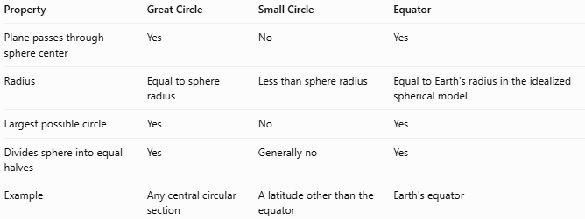
Property | Great Circle | Small Circle | Equator
Plane passes through sphere center | Yes | No | Yes
Radius | Equal to sphere radius | Less than sphere radius | Equal to Earth's radius in the idealized spherical model
Largest possible circle | Yes | No | Yes
Divides sphere into equal halves | Yes | Generally no | Yes
Example | Any central circular section | A latitude other than the equator | Earth's equator

Applications
# Source: AI Source: Provided by: [Data Path: Persons Table -> ID Column: 1, Name_En Column: Motasem Essam] -> From: [ChatGPT] on [7/25/2026]
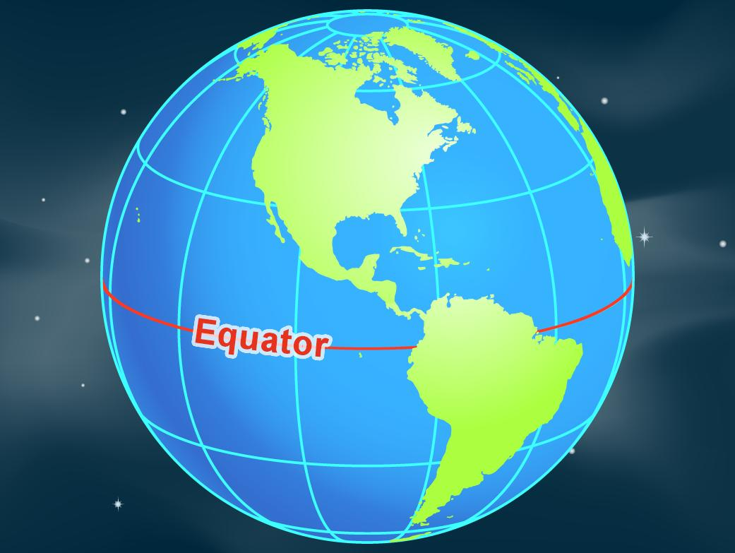
Geography
The equator is a great circle used to divide Earth into the Northern and Southern Hemispheres.
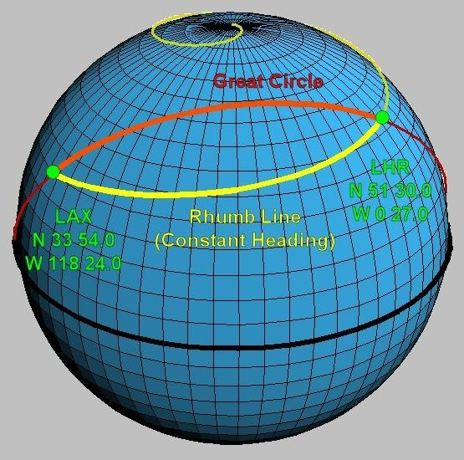
Navigation
Great-circle routes provide the shortest surface paths between two points on an ideal spherical Earth, when the points are not antipodal.
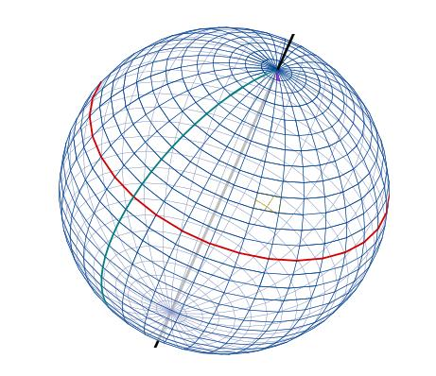
Astronomy
Great circles are used to describe coordinate systems and angular relationships on the celestial sphere.
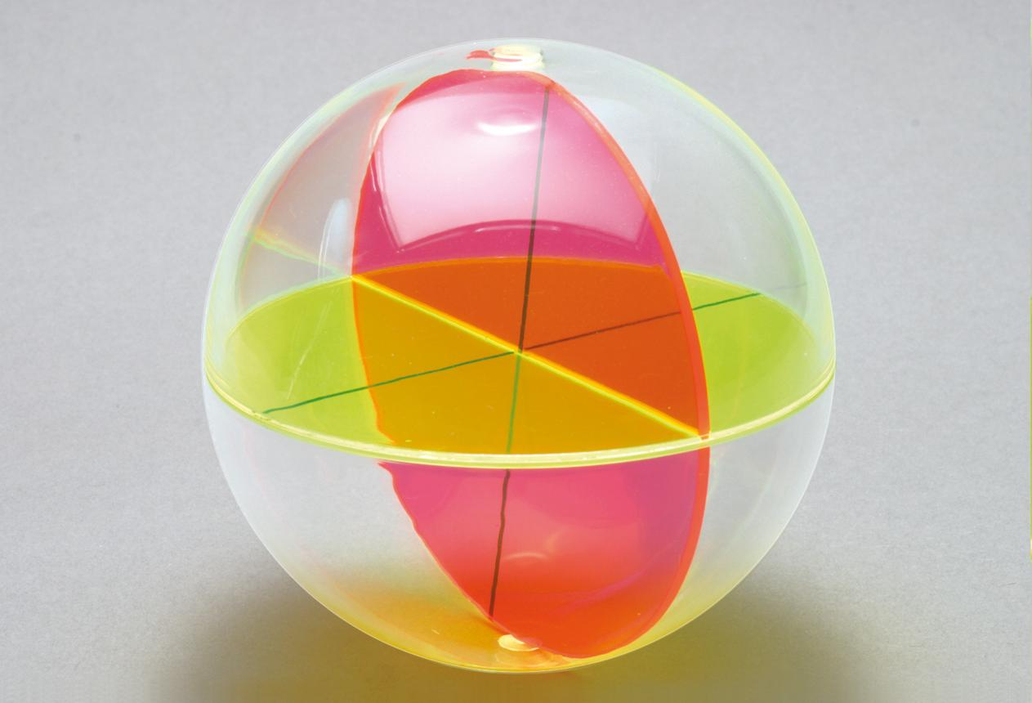
Geometry
Great circles help explain spherical sections, symmetry, and the geometry of spheres.

Key Points
# Source: AI Source: Provided by: [Data Path: Persons Table -> ID Column: 1, Name_En Column: Motasem Essam] -> From: [ChatGPT] on [7/25/2026]
- A great circle is formed when a plane passes through the center of a sphere.
- It has the same radius as the sphere.
- It is the largest possible circle on the sphere.
- Its circumference is $C=2πR$.
- Its enclosed disk area is $A=πR^{2}$.
- It divides a sphere into two equal hemispheres.
- A small circle is formed when the cutting plane does not pass through the sphere's center.

Conclusion
# Source: AI Source: Provided by: [Data Path: Persons Table -> ID Column: 1, Name_En Column: Motasem Essam] -> From: [ChatGPT] on [7/25/2026]
A great circle is the largest circle that can be formed on a sphere because its plane passes through the sphere's center. Its radius equals the sphere's radius, and it divides the sphere into two equal hemispheres. Great circles are fundamental to spherical geometry and have important applications in geography, navigation, and astronomy.

